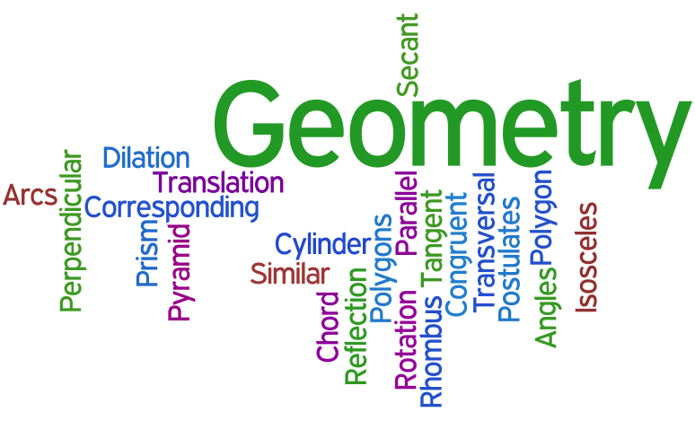

2nd Grade, Cass Lake-Bena Elementary School

Veronica Kleefeld, vkleefeld@clbs.k12.mn.us

Tila Basar, tbasar@clbs.k12.mn.us

Executive Summary
This unit is designed, with some whole group instruction and hands on activities, to teach the children how to: analyze, recognize, and classify different geometric shapes and angles; understand that the size of the unit impacts the number of units needed to measure the length of an object; understand the relationship between the numbers on a ruler and length; and accurately measure an object to the nearest centimeter and inch using a ruler.

The Minnesota State Math Standards specifically built into this unit are:

Identify, describe and compare basic shapes according to their geometric attributes.

2.3.1.1 Describe, compare, and classify two- and three-dimensional figures according to number and shape of faces, and the number of sides, edges and vertices (corners). Identify, describe and compare basic shapes according to their geometric attributes.

2.3.1.2 Identify and name basic two- and three-dimensional shapes, such as squares, circles, triangles, rectangles, trapezoids, hexagons, cubes, rectangular prisms, cones, cylinders and spheres.

Understand length as a measurable attribute; use tools to measure length.

2.3.2.1 Understand the relationship between the size of the unit of measurement and the number of units needed to measure the length of an object.

2.3.2.2 Demonstrate an understanding of the relationship between length and the numbers on a ruler by using a ruler to measure lengths to the nearest centimeter or inch.

Table of Contents
Lesson Page
Pre/Post Test 4
Day 1 Squares, Rectangles, and Triangles 6
Day 2 Sides and Vertices 10
Day 3 Two Dimensional Shapes 15
Day 4 The Shape Game 18
Day 5 Compare and Classify Angles 20
Day 6 Planning a Dinner Party With 23
Day 7 Perimeter is All Around 24
Day 8 Straw Polygons 26
Day 9 Perimeter with Geoboards 28
Day 10 Perimeter Is Here, There, and Everywhere 30
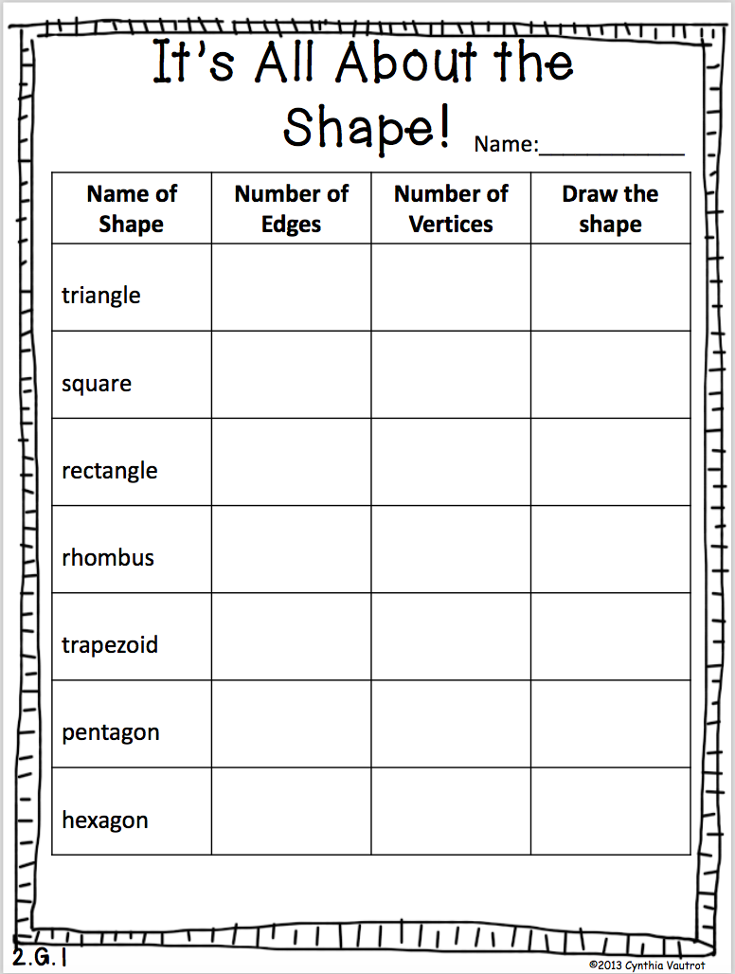

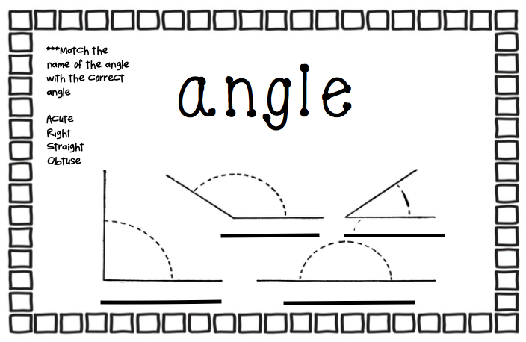

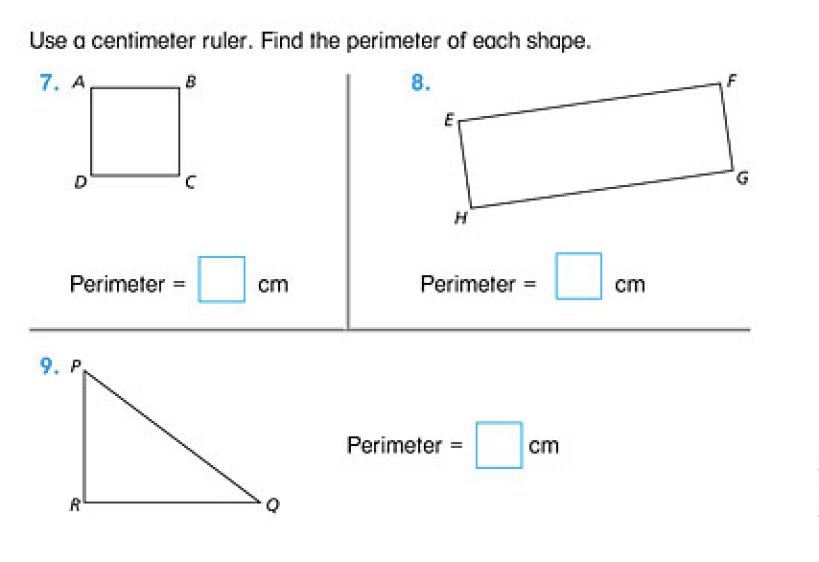
Day 1 Squares, Rectangles, and Triangles (Grade 2 Math Expressions Unit 2 Lesson 2)

MN State Standards: 2.3.1.1, 2.3.1.2, 2.3.2.2

Materials Needed: MathBoard materials, cm rulers, My Shapes and Angles Book

Objective: Describe properties of squares, rectangles, and triangles. Vocabulary: square, rectangle, and triangle

Pretest: Give Unit Test in the Student Activity Book (page 139)

Activity 1 Launch: Draw a square on the board. Tell children that a small square drawn on a shape shows a square corner.
· What is the name of this shape? (Square)
· How many sides does a square have? (4)
· How many corners does a square have? (4)
Have children sketch several squares on their MathBoards, drawing freehand or using a centimeter ruler.
· How can you describe the sides of a square? (Each side is a straight line; all sides are the same length.)
· How can you describe the corners of a square? (A horizontal line meets a vertical line at each corner; all four corners are square corners.)
Draw a rectangle on the board.
· What is the name of this shape? (rectangle)
· How many sides does a rectangle have? (4)
· How many corners does a rectangle have? (4)
Have children sketch several rectangles on their MathBoards, drawing freehand or using a centimeter ruler.
· How can you describe the sides of a rectangle? (Rectangles have 4 sides and the 2 sides opposite each other are equal in length.)
· How can you describe the corners of a rectangle? (Rectangles have square corners.)
Ask children to tilt their MathBoards.
· If you tilt a rectangle, is it still a rectangle? (yes)
Have the children compare the squares and rectangles on the board.
· How are rectangles like squares? (They have 4 square corners and opposite sides of the same length.
· How are rectangles different from squares? (All 4 sides don’t have to be the same length.)
Draw three different triangles on the board.
· What is the name of these shapes? (triangles)
· How many sides does a triangle have? (3)
· How many corners does a triangle have? (3)
· Invite children to sketch several triangles on their MathBoards, drawing freehand or using a centimeter ruler.

Explore: Invite children to work in pairs to write what they know about squares, rectangles, and triangles in their Shapes and Angles Book.
Share: The children come together to discuss and share what they wrote in their books.

Summarize: Review with the children the properties of squares, rectangles, and triangles. Children will see that squares and rectangles have “square corners”. They will also explore triangles.
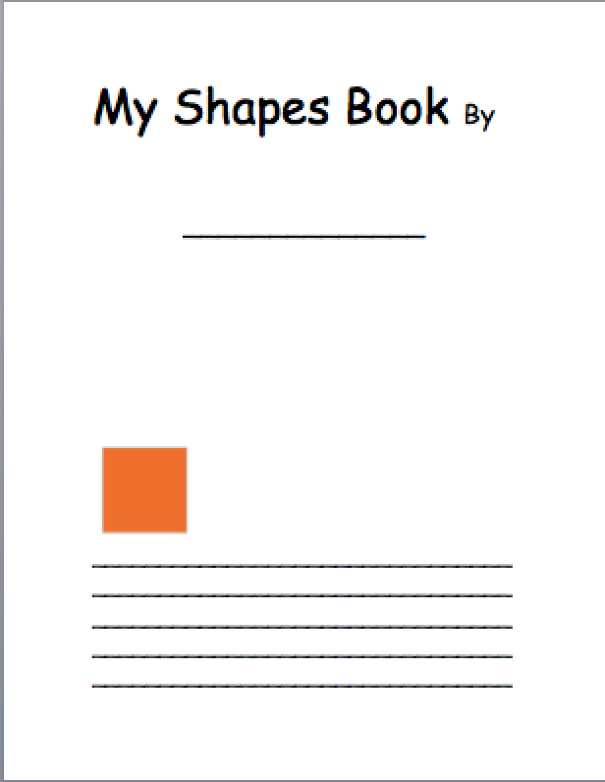

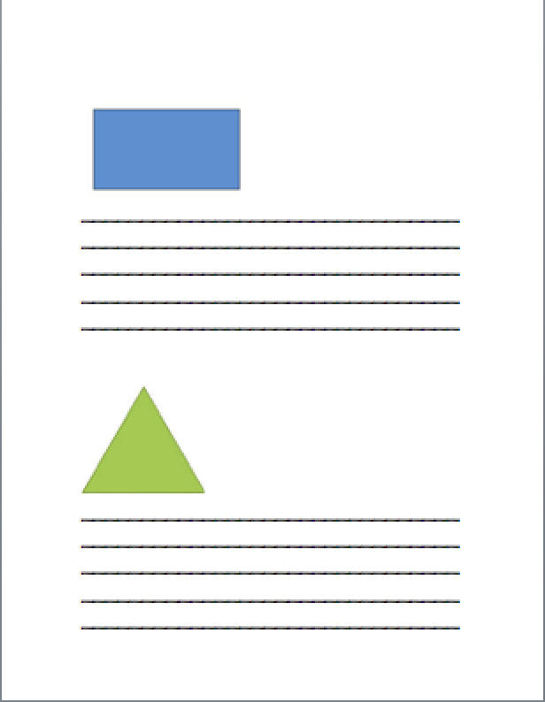
Day 2 Sides and Vertices Lesson Materials are from:
https://www.teacherspayteachers.com/Product/No-Prep-Geometry-Unit-1st-2nd-Grade-CCSS-2137217

MN Standards: 2.3.1.1, 2.3.1.2, 2.3.2.2

Materials: Play dough and popsicle sticks/toothpicks, Anchor chart with vocabulary words taped or glued on it.

Objective: Show or explain what a side/edge is. Show or explain what a vertices/corner is.

Launch: Ask children if they have ever played with Legos. Discuss the different objects they made. Show a figure card and ask if children have ever made that figure before. Ask if anyone can build it using the sticks. Choose a child or 2 to “build” the shape with ONLY the sticks. Children will see that without corners, the edges don’t “stick” together. Give children some play dough so they can build the figure properly. Repeat this with several cards. When children come to build, ask: ***If the terms are unknown, stop and explain the unknown word and then repeat the question**
• How many sides/edges do you need?
• How many corners?
Explore: Pair the children and give each pair one card. Ask children to identify how many edges and corners are needed to build that shape.
Share: When children decide, they will take turns coming to the anchor chart and gluing their figure to the page. Students will write “___ edges” and “___ corners” beside their piece. ***If they get stuck, they may POLL the audience. After all of the pieces have been glued to the anchor chart, ask these questions.
Summary: Questioning-
· Review what a side is.
· Review what a corner/vertices is.
· Review the purpose of the corners (to hold the figure together)

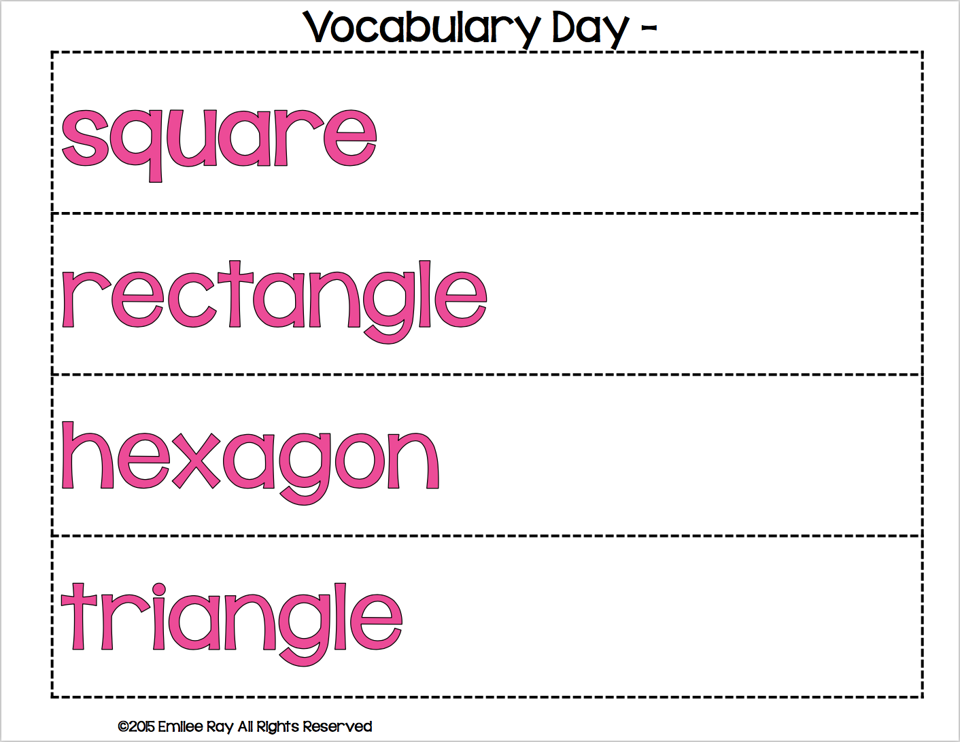
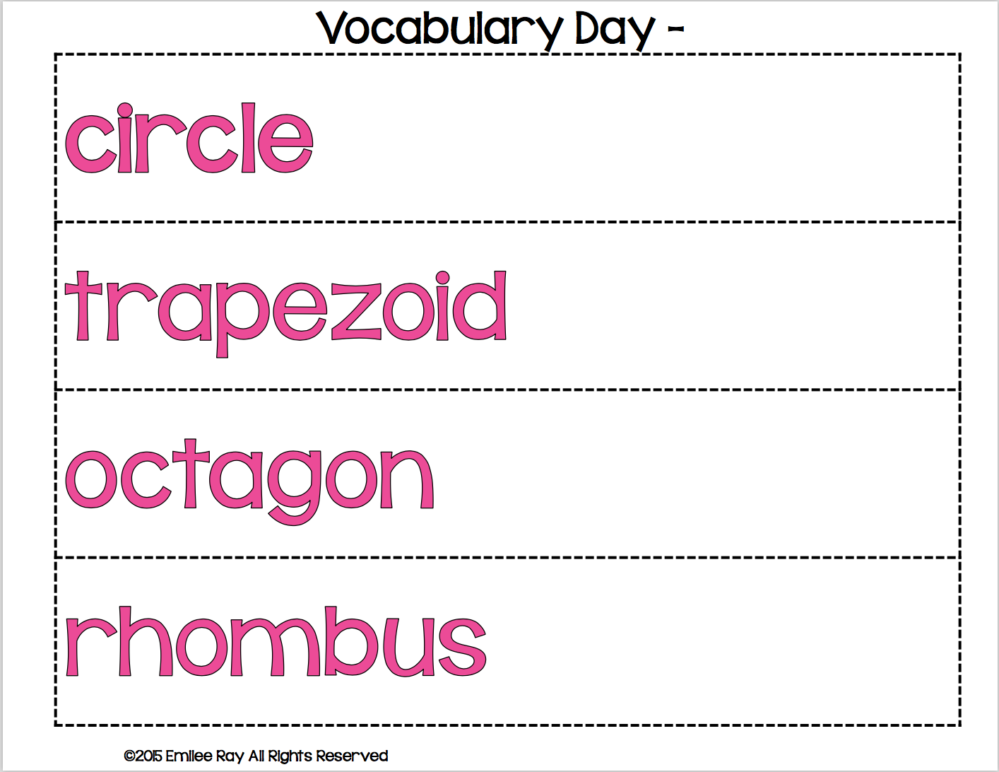
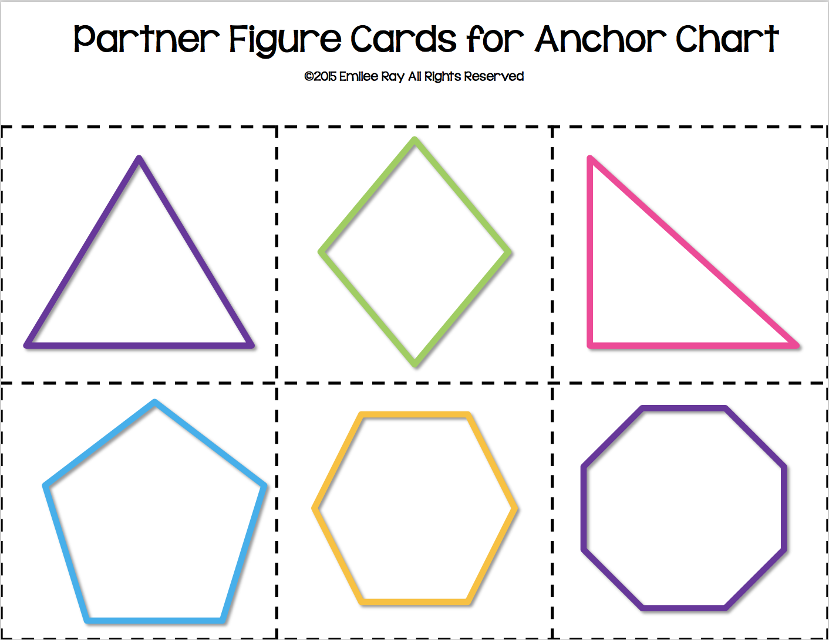

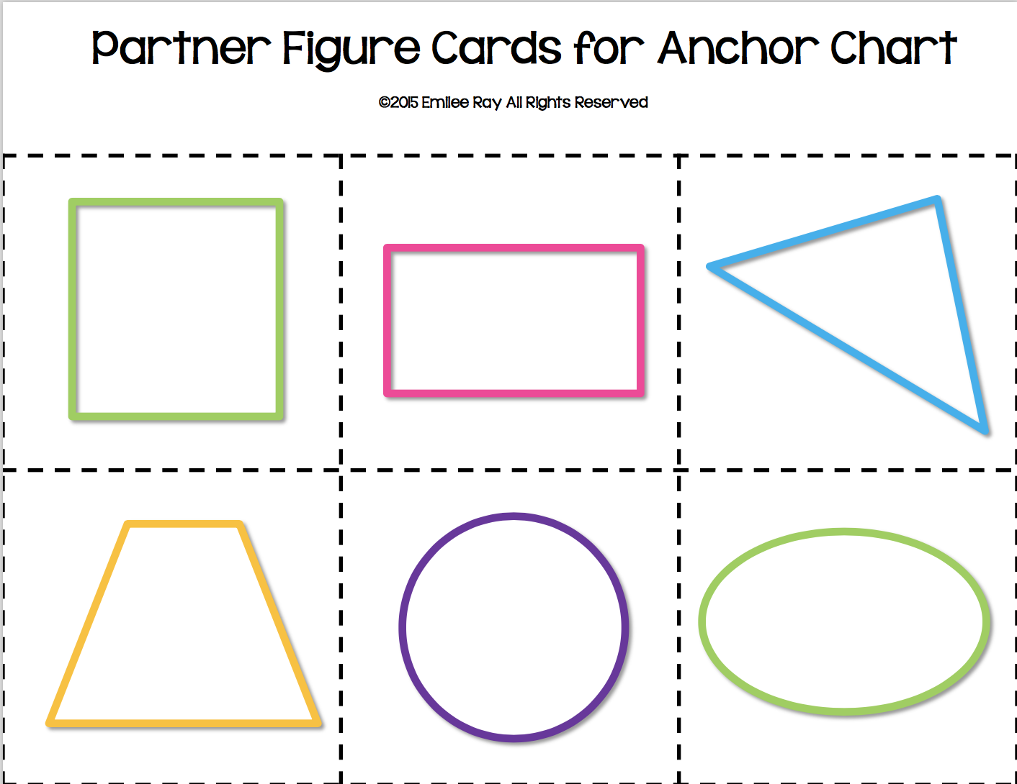

Day 3-Two Dimensional Shapes Lesson Materials are from: https://www.teacherspayteachers.com/Product/No-Prep-Geometry-Unit-1st-2nd-Grade-CCSS-2137217

MN State Standards: 2.3.1.1, 2.3.1.2, 2.3.2.2
Materials: Math Interactive Notebooks, glue, scissors, anchor chart from the day before

Objective: Name and describe squares, rectangles, triangles, hexagons, circles, trapezoids, octagon, and rhombus

Launch: Review different shapes from the anchor chart from the day before (square, rectangle, triangle, hexagon, circle, trapezoid, octagon, and rhombus).

Explore: Group the children in pairs and have them cut out the two-dimensional shapes on the first worksheet and glue them in categories (3 sides, 4 sides, 5 or more sides, and curved) in their math notebooks. For the table worksheet, have children cut along the outside dotted line and glue the page into their math notebooks. Children should fill in the answers on their own.

Share: Once they have filled in their shapes worksheet, they can check with a partner to see if they have their answers right.

Summary: Have children come up to the board to help teacher match shapes to categories on the elmo.

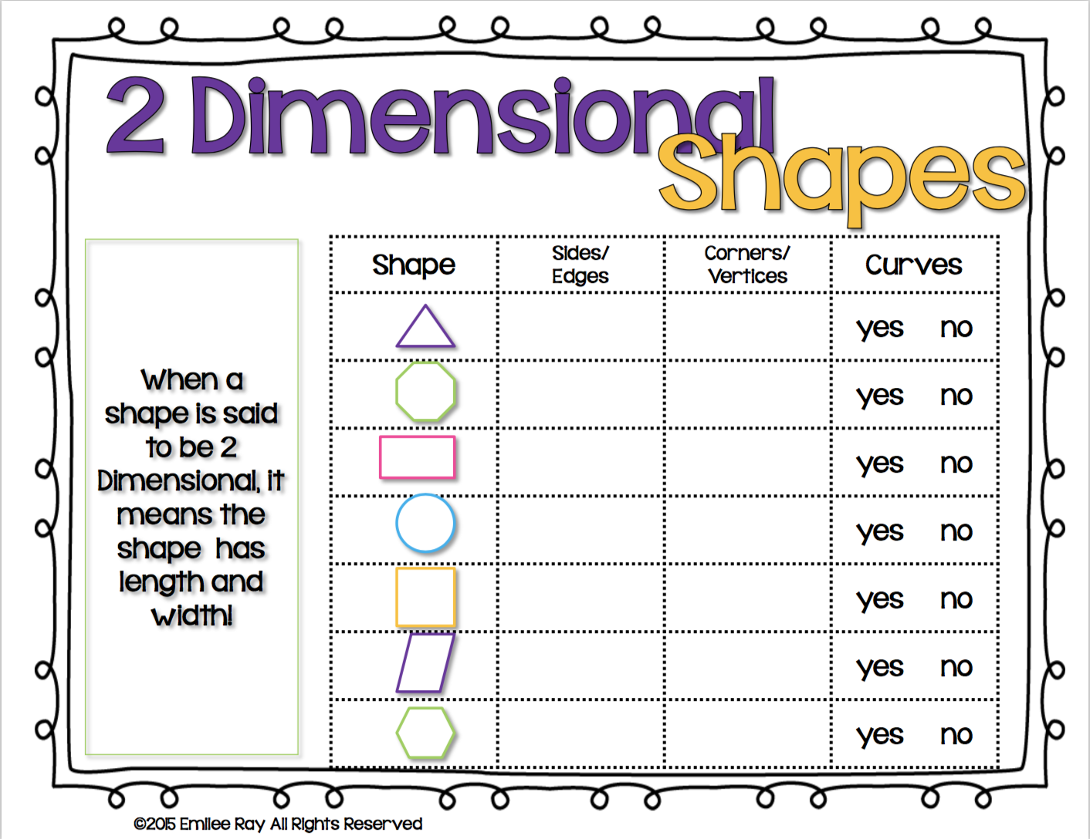

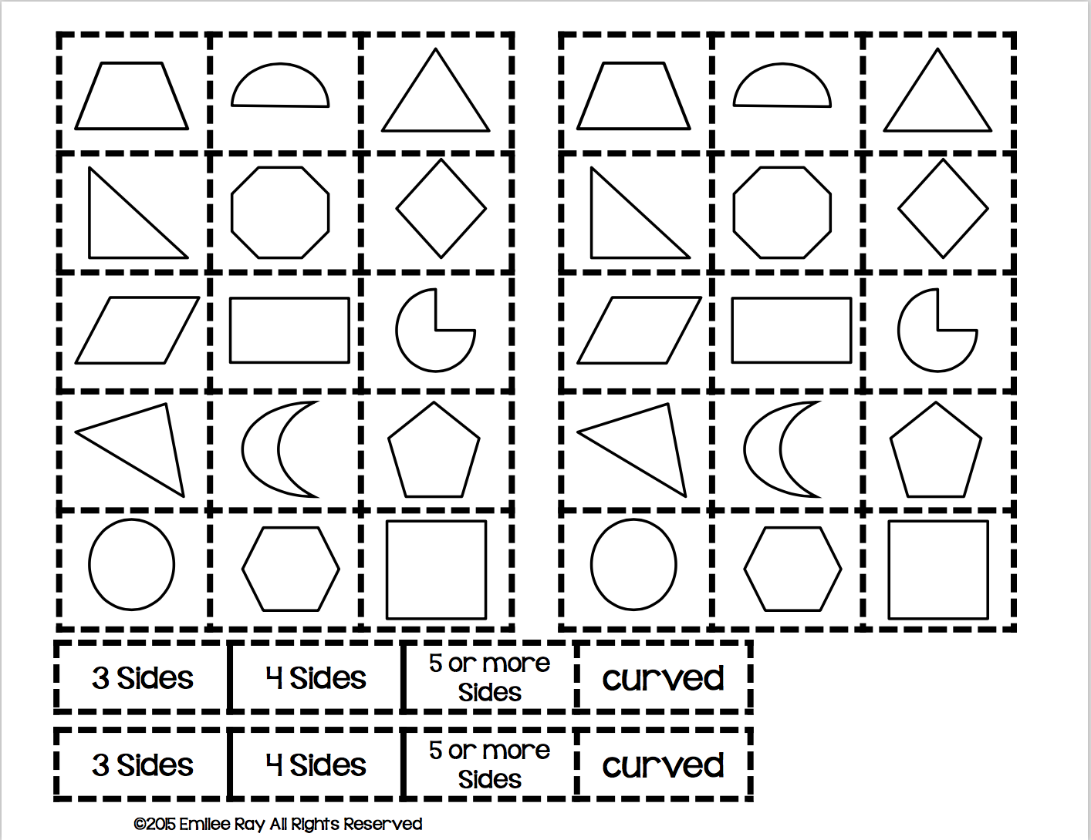

Day 4-The Shape Game

MN State Standards: 2.3.1.1

Materials-Dice, colored pencils or crayons, The Shape Game worksheet for each student found here: https://www.tes.com/teaching-resource/2d-shape-resources-3006082 A scanned copy is included in this packet, but printing it from online is better.

Objective- Students will practice counting sides of shapes in centers using The Shape Game

Launch: Share rules of The Shape Game with children, letting them know that they will have practice counting sides of shapes while playing a game. Divide children in groups for centers and make sure all materials listed are available.

Explore: Children will play The Shape Game in their centers practicing counting sides while having fun.

Share: Have children share their game boards with the class.

Summary: As a closure to the game, have children refer to the anchor chart and write in the names of their shapes on their game boards and include the number of sides each shape has.

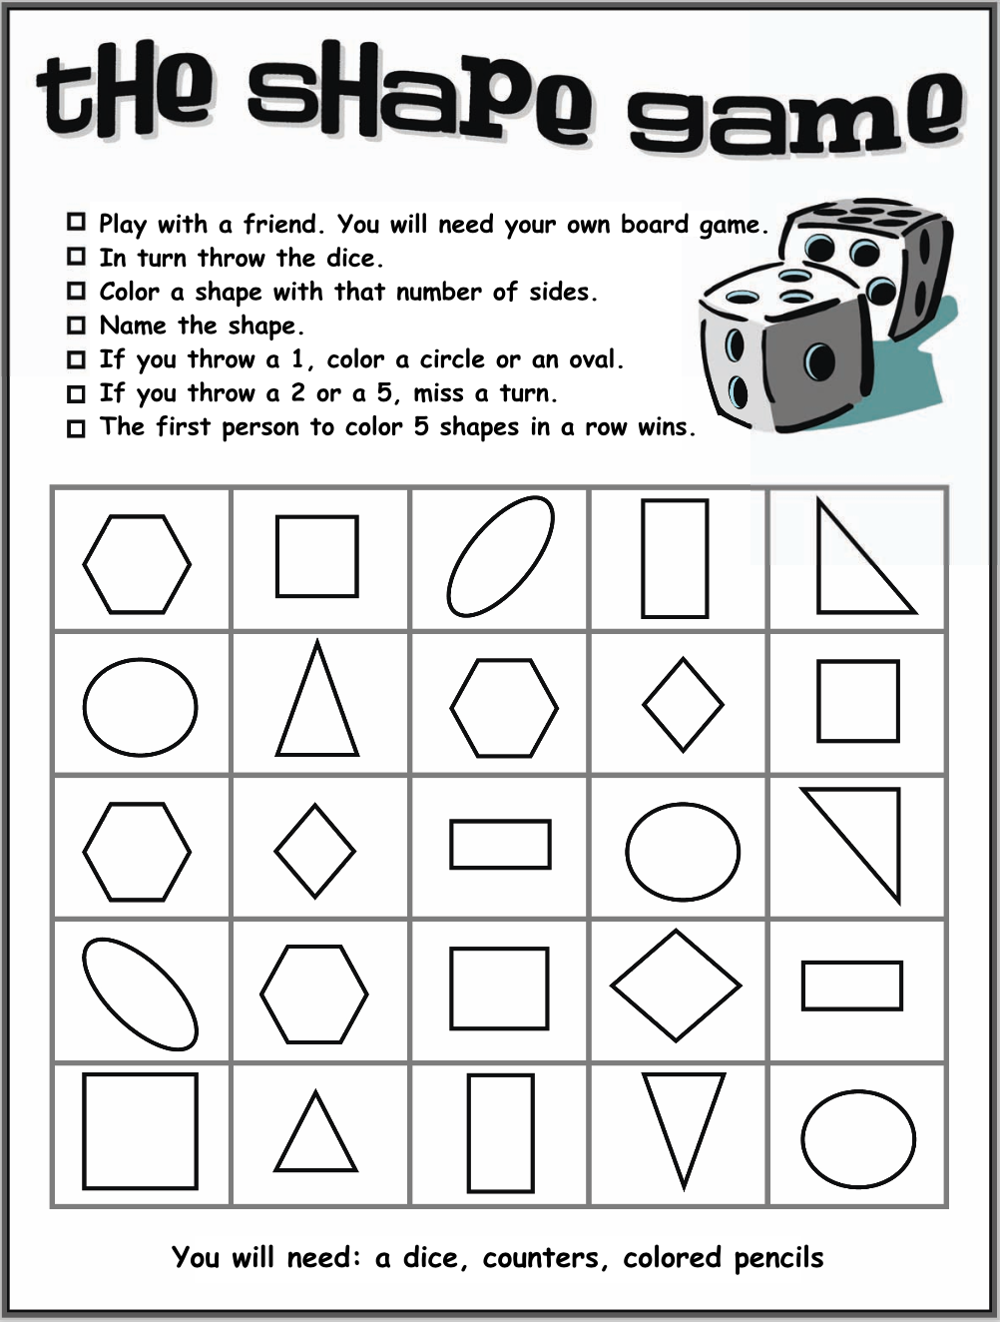

Day 5 Compare and Classify Angles (Grade 2 Math Expressions Unit 4 Lesson 1)

MN State Standards: 2.1.2.2, 2.2.1.1

Materials: Anchor Chart displaying Obtuse, Acute, and Square Corner Angles, 2 cm rulers for each child (or two for a pair), centimeter dot paper,

Objective: Classify angles in triangles. Vocabulary: Obtuse, Acute, Square Corner Triangles

Launch: Demonstrate how to use two rulers to make angles of different sizes. Show children how to trace the inside of an angle and how to add a third line to create a triangle. Have children use the centimeter dot paper to draw a small angle, a large angle and a square angle. Use the anchor chart to talk about and describe Obtuse, Acute, and Square Corner angles. Play Youtube song: https://www.youtube.com/watch?v=NVuMULQjb3o

Explore: Ask children to draw 10 triangles on blank paper. Challenge them to make each triangle unique by varying the size of the angles and the number of equal sides.

Share: When children are finished, have them cut out each of their triangles. Invite children to work in pairs to share and organize their triangles into three groups and talk about their different characteristics.

Summary: Circle up the children and review obtuse, acute, and square corner angles.

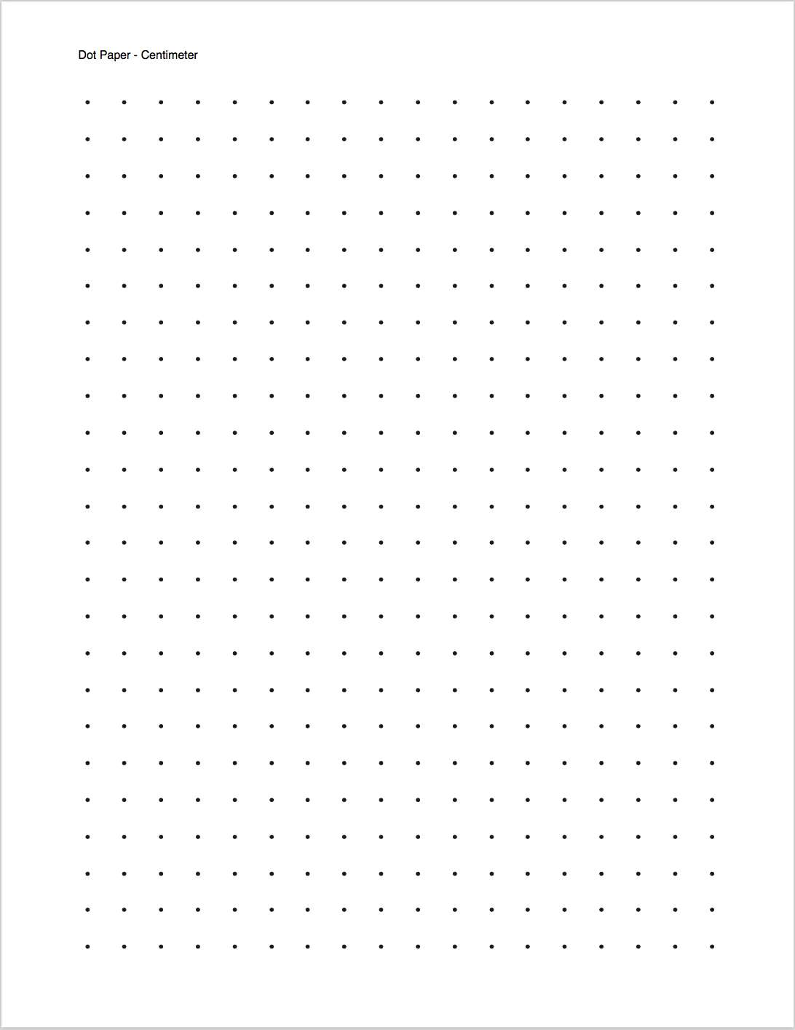
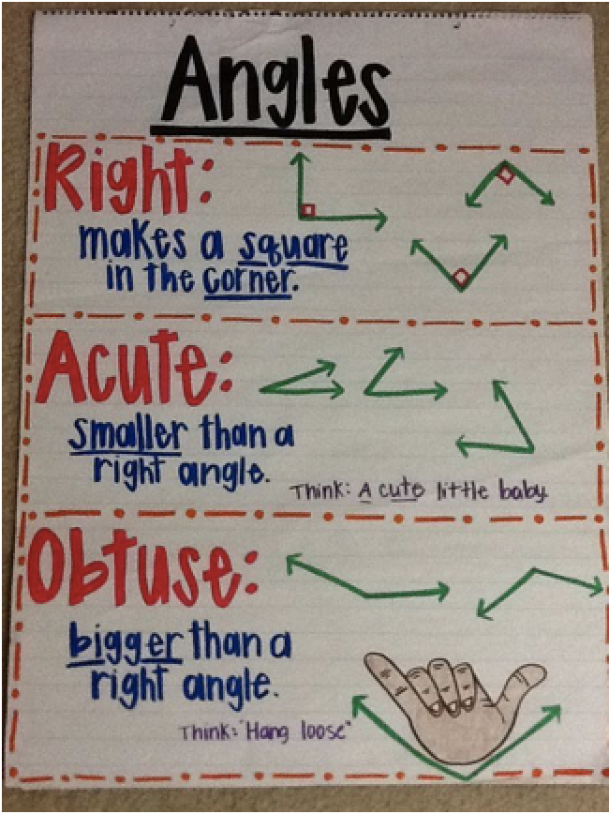
Day 6 Planning a Dinner Party

Objective: Students will explore the concept that distance around the outside of a shape is the perimeter.

Materials: 8 large squares and 32 small squares, for each group; Burns, M. (2008) Spaghetti and Meatballs for All! ISBN-10: 0545044456 Scholastic Paperbacks; https://www.youtube.com/watch?v=jN_GmgeU5cw

Launch: Read/watch the book Spaghetti and Meatballs for All! up until the guests begin to move the tables. Tell the class that they are going to help Mrs. Comfort set her tables so that everyone is happy.

Explore: Students will work in pairs. Each pair gets eight squares that represent the tables and 32 smaller squares for the guests. The pairs will work together to figure out how to set the tables so that 32 guests can sit.

Share: Class discussion about how to set the tables so that all 32 guests can sit at a table.

Summarize: Finish the book Spaghetti and Meatballs for All! After the story has finished, ask the students “how could the tables be arranged for 26 guests?” Continue with 24, 22, etc.

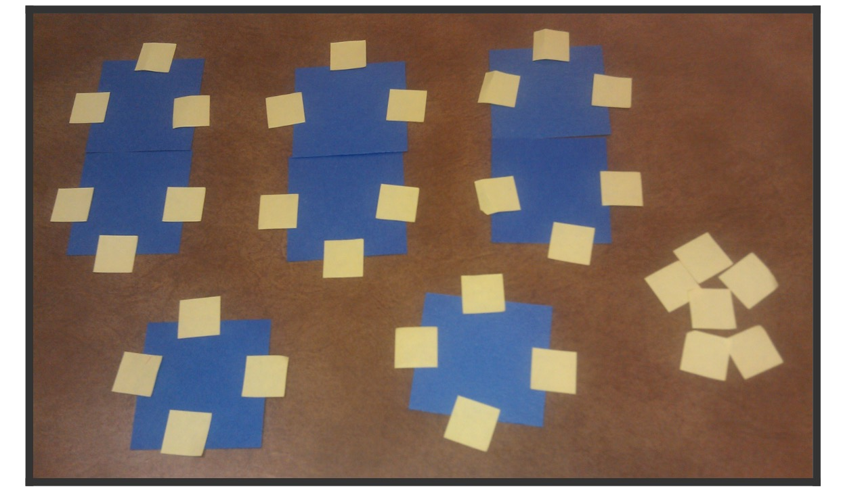
Connell, G. (2012, December 13). 10 Hands-On Strategies for Teaching Area and Perimeter. Retrieved from https://www.scholastic.com/teachers/blog-posts/genia-connell/10-hands-strategies-teaching-area-and-perimeter/
Day 7 Perimeter is All Around

MN State Standards: 2.3.2.1, 2.3.2.2

Objective: Children will find the perimeter of different polygons.

Materials: crayon or marker, centimeter ruler, document camera, centimeter grid paper https://www.template.net/business/paper-templates/graph-paper/

Launch: Using the shapes from day 2, hold up a rectangle, ask the class “what shape is this?” Have the students draw a 2x4 rectangle on their centimeter grid paper. Ask the class “how many spaces are on the left side?” (continue with bottom, right, top) After the students have counted the spaces, have them check the length with their centimeter ruler. After the lengths have been confirmed with the ruler, model how to add the numbers together to get the perimeter. make sure the class understands that perimeter is the distance around the outside of a shape. After the rectangle is done find the perimeter of a square, triangle, and a trapezoid.

Explore: On the centimeter grid paper, students can create their own shapes and record the perimeters.

Share: With a partner, the students will share the shapes they have created and check to make sure they counted and added correctly. The pair will then pick their favorite polygon to share with the class.
Summarize: Perimeter is the distance around the outside of a shape. The teacher will create one new shape on a centimeter grid paper, under the document camera, the class will work together to find the perimeter.
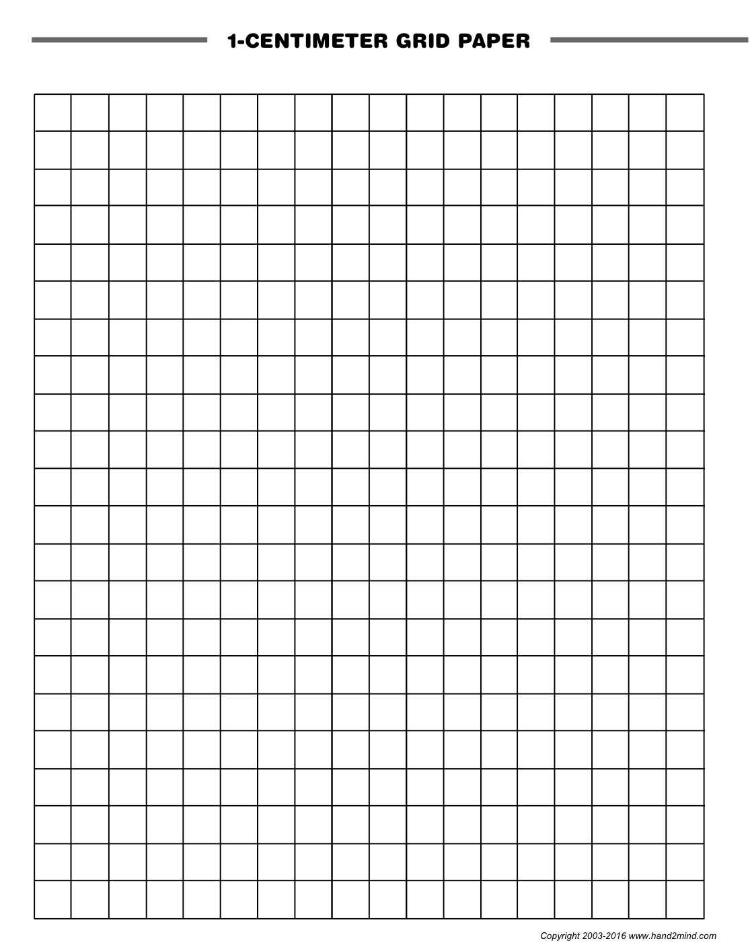

Day 7 Straw Polygons

MN State Standards: 2.3.2.2

Objective: Students will explore perimeter by making polygons with sides of various lengths.

Materials: straws cut into lengths of 4, 6, and 8 centimeters; centimeter ruler; blank paper; pencil

Launch: Review that perimeter is the distance around the outside of a shape. Inform the class that they are going to my polygons out of straw.

Explore: Give each child a bag that contains a variety of four, six, and eight centimeter straws. The students need to create their own polygon, out of the straws. Once they have made a polygon, they need to record the shape, the length of each line, and the total perimeter on a blank piece of paper. Until it is time to share, The children can continue to make shapes and record their information on the blank piece of paper.

Share: Have the students share their polygon(s) with a partner. While the students are sharing, the teacher will pick two student examples for the class to look at and talk about.
Summarize: Ask the class, “what is perimeter?” The distance around the outside of a shape. Create an anchor chart for perimeter.
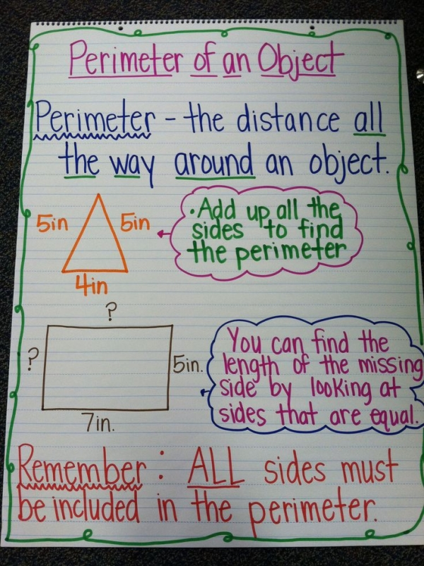
Day 8 Perimeter with Geoboards

Objective: Students will use geoboards to create shapes with different perimeters.

Materials: Geoboards, rubber bands, perimeter worksheet, pencil

Launch: Review the perimeter anchor chart that was made the day before. Inform the class that they are going to make different shapes on a geoboard. Teacher will model how to make a square with a perimeter of 4. (Continue to make different shapes: triangle with a perimeter of 6, rectangle with a perimeter of 10, etc.)

Explore: Students will create four different shapes on their geoboard. Once the shape has been made, the student will record the shape and perimeter on their paper.

Share: Have students share one of the four shapes they made with the class. Have a class discussion to see how many students made the same shapes.

Summarize: Ask the class, “what is perimeter?” The distance around the outside of a shape. Make a shape on a geoboard and as a class find the perimeter of the shape.

Name ________________________________________

Perimeter is the distance around the outside of a shape.

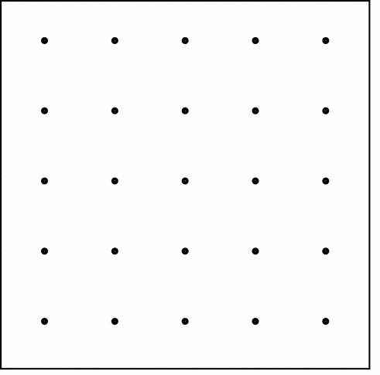
P = |  | P =
P = |  | P =
Day 9 Perimeter Is Here, There, and Everywhere

MN State Standards: 2.3.2.1, 2.3.2.2

Objective: Students will measure perimeter by using rulers and yardsticks to measure large shapes that are on the floor.

Materials: tape to create seven large polygons (mark each side with letter, and each shape should be given a letter name), student worksheet, pencil, rulers, yardsticks, tape measures

Launch: Review perimeter anchor chart. “What is the perimeter of these shapes?” As a class, find the perimeter of questions 3, 4, 7, and 8 from Math Expressions Unit 2, days 3-4. Tell the class “today, you are going to work in groups to find the perimeter of the shapes on the floor.”

Explore: Working in groups of three, students use rulers, yardsticks, and tape measures to record the length of each side, and then they add them together.

Once the students have finished measuring the floor polygons, the students are free to explore perimeter of everyday items in the classroom (rugs, cabinet doors, tables, etc.) and recording them in the last five spaces of their worksheet.

Share: Once all groups have finished finding the perimeter of the shapes on the floor, have the students go back to their table spots. The table groups will then compare their results and share what objects they measured in the classroom.

Summarize: As a class, discuss the length of each side and the perimeter of each shape that is on the floor.
Student workbook pages from Math Expressions Unit 2, days 3-4

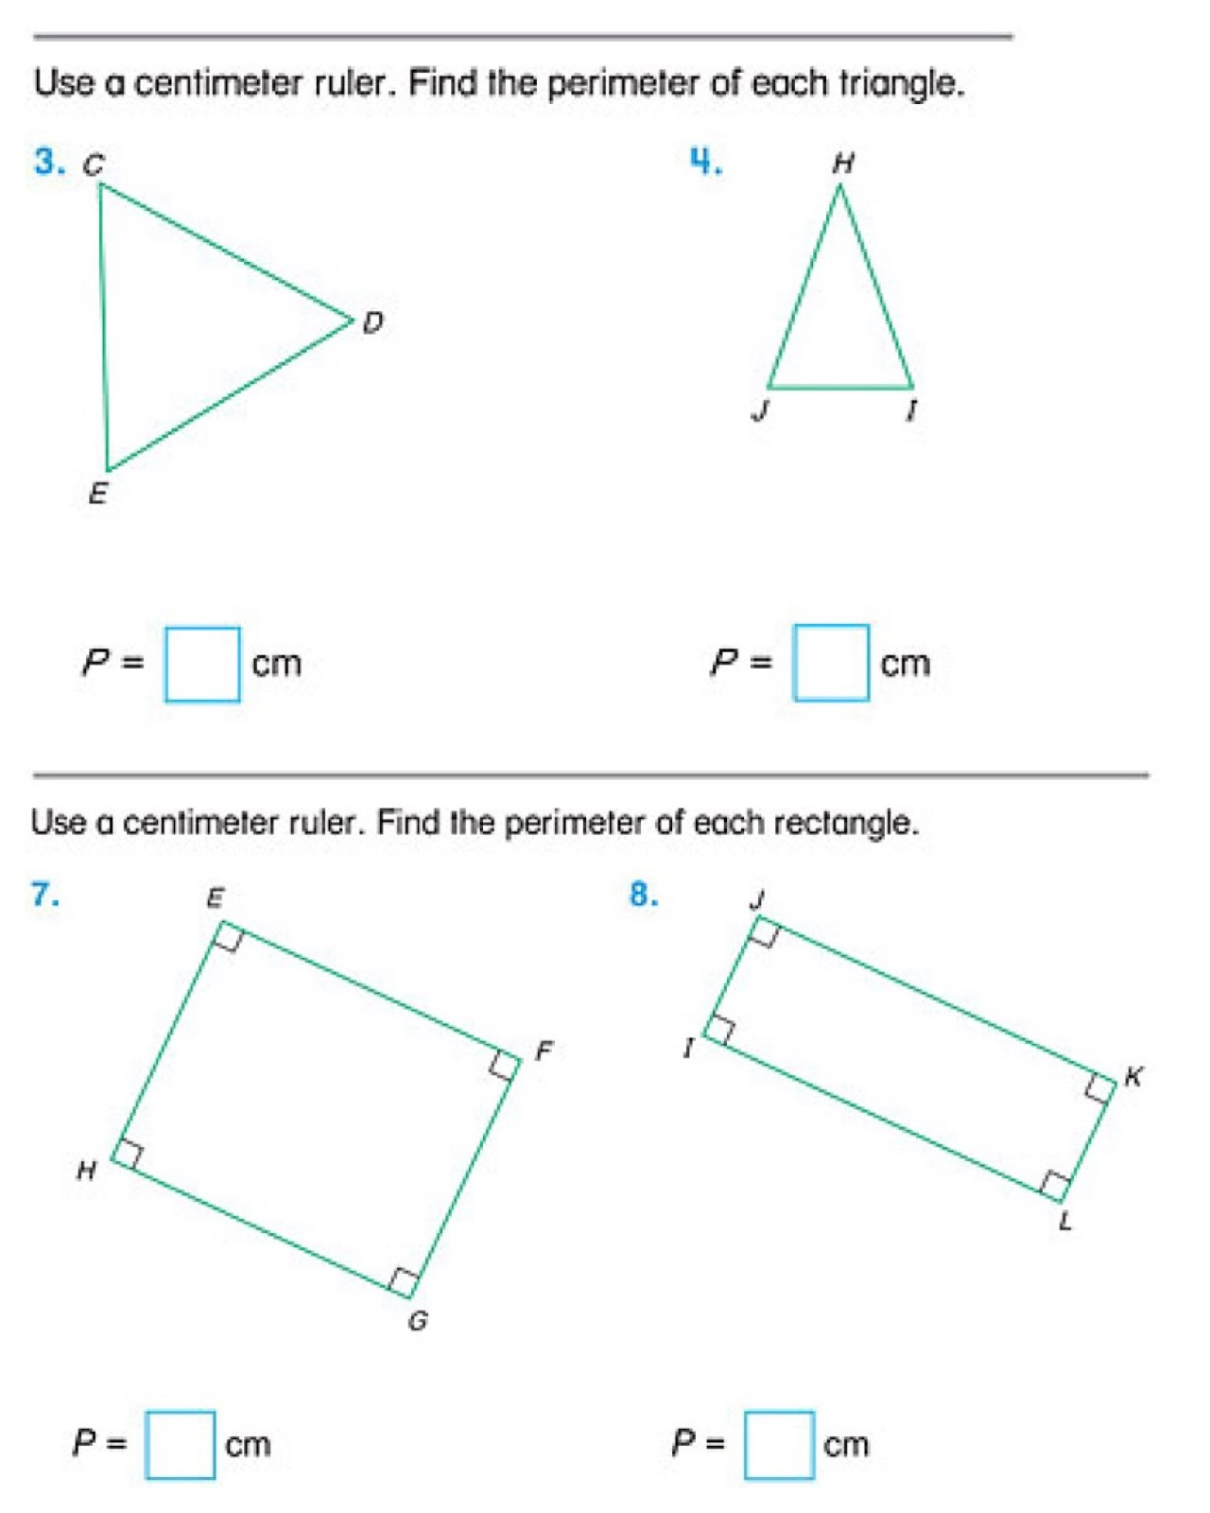

 |  |  |  |  | G Parallelogram | F Rectangle | E Pentagon | D Triangle | C Trapezoid | B Pentagon | A Square | Shape | Perimeters Around the Room
 |  |  |  |  |  |  |  |  |  |  |  | Side 1 | Perimeters Around the Room
 |  |  |  |  |  |  |  |  |  |  |  | Side 2 | Perimeters Around the Room
 |  |  |  |  |  |  |  |  |  |  |  | Side 3 | Perimeters Around the Room
 |  |  |  |  |  |  |  |  |  |  |  | Side 4 | Perimeters Around the Room
 |  |  |  |  |  |  |  |  |  |  |  | Side 5 | Perimeters Around the Room
 |  |  |  |  |  |  |  |  |  |  |  | TOTAL | Perimeters Around the Room

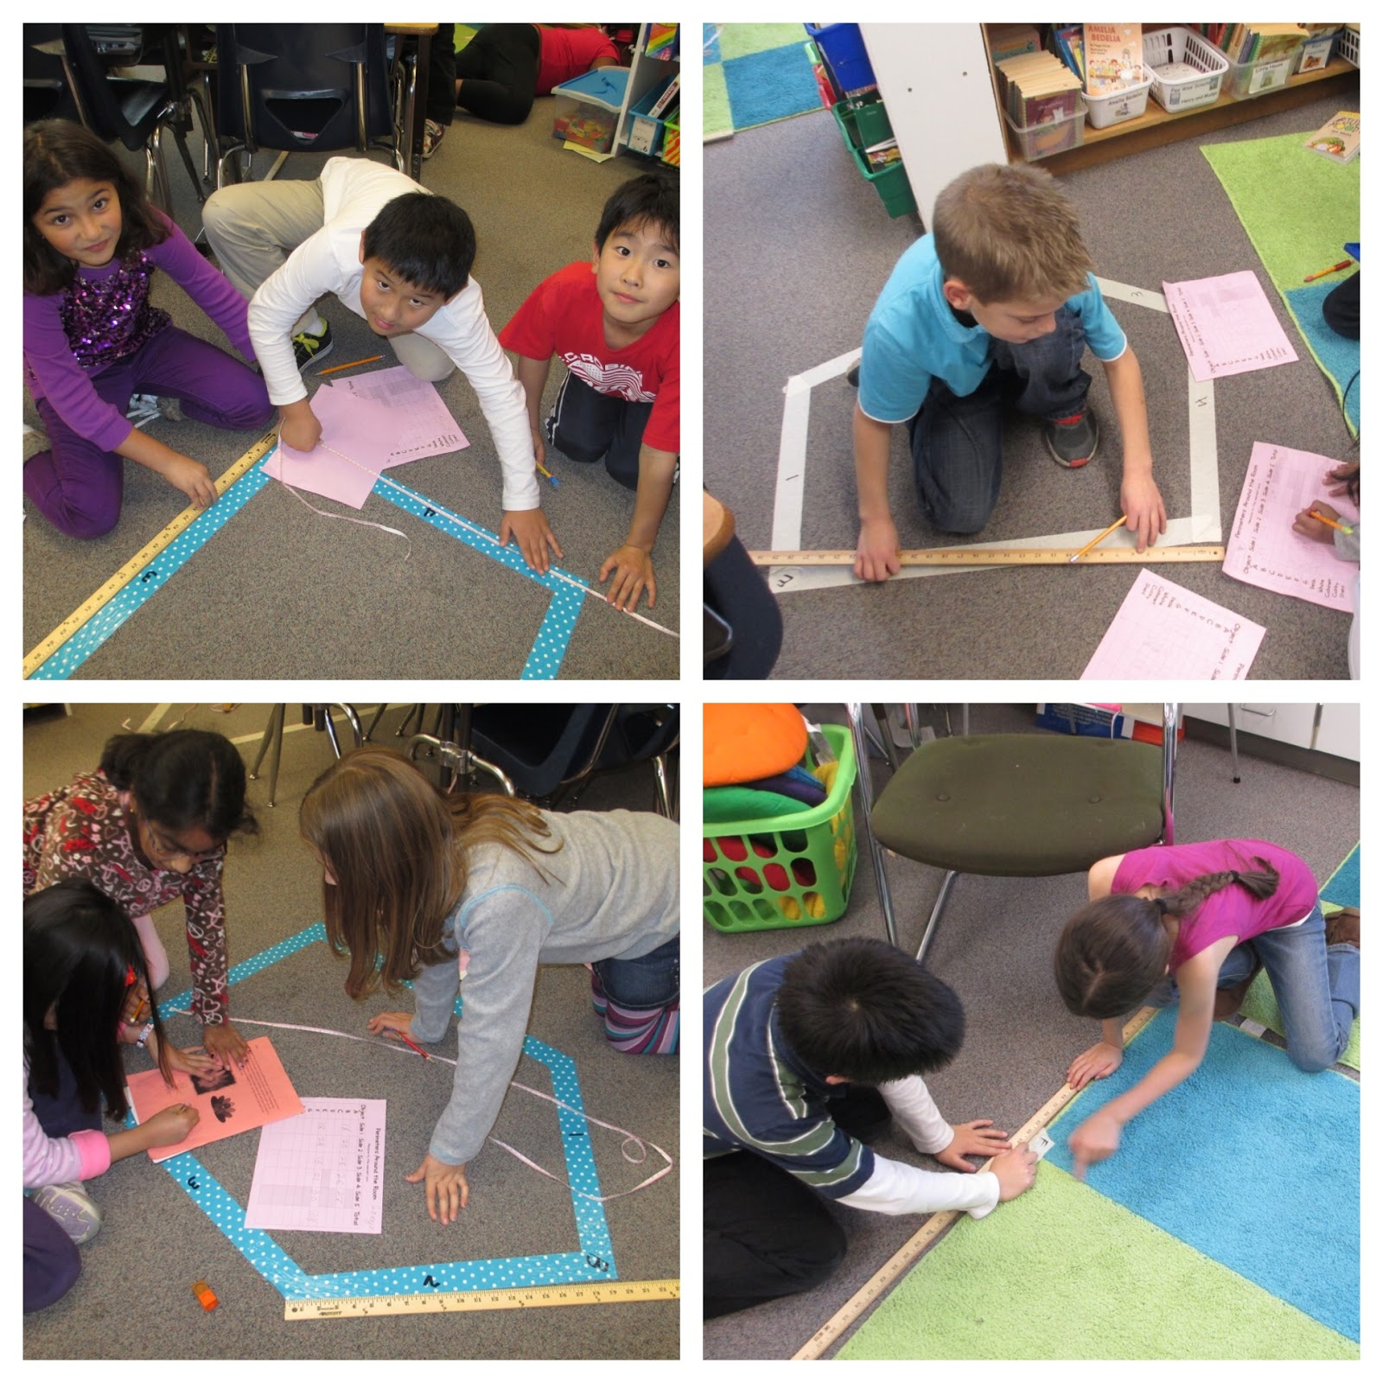
Connell, G. (2012, December 13). 10 Hands-On Strategies for Teaching Area and Perimeter. Retrieved from https://www.scholastic.com/teachers/blog-posts/genia-connell/10-hands-strategies-teaching-area-and-perimeter/

